Practical - 1
Practical Title: Project Initiation, Requirement Analysis, Sitemap, Wireframe, and GitHub Setup

Problem Definition 1: Initiate the semester-long StudentHub portal by identifying the problem scope, user roles, key modules, navigation flow, and minimum 10 pages. Create a sitemap, low-fidelity wireframe, project folder structure, README file, and GitHub repository.

Theory

What is URL and parts of URL?
Answer: URL means (Uniform Resource Locator) . It is the address of something on the internet. It have parts like:
1)Protocol: https or http
2)Domain name: Host’s Name
3)Port Number: 443,200,etc
4)Path: Specific address to something in the internet.
I used the help of Google Gemini and ChatGpt.

How does HTML file process in web browser?
Answer:
User Opens URL / HTML File
│
▼
Browser Sends Request
│
▼
Server Returns HTML File
│
▼
Browser Parses HTML
│
▼
Creates DOM
│
▼
Loads CSS & JavaScript
│
▼
Renders and Displays Webpage

References: Duckett, J. (2021). HTML and CSS: Design and Build Websites. John Wiley & Sons.

3. How will page navigation flow managed among all HTML pages?
Answer: A sitemap is an important part of a website because it improves navigation for users and helps search engines understand the website's structure. This makes the website more user-friendly and improves its visibility in search engine results.
Uses of a Sitemap
- Improves Website Navigation
  - A sitemap helps visitors quickly locate the information or page they are looking for.
- Helps Search Engines
  - Search engines use sitemaps to find and index website pages, making them easier to appear in search results.
- Organizes Website Structure
  - It provides a clear overview of all the pages and their relationships within the website.
- Speeds Up Indexing
  - Newly added or updated pages can be discovered and indexed faster by search engines.
- Useful for Large Websites
  - Websites with many pages benefit from sitemaps because they make content easier to manage and access.
References:
• Duckett, J. (2021). HTML and CSS: Design and Build Websites. John Wiley & Sons.

4. How will GitHub commits be maintained after each practical?
Answer: GitHub commits should be maintained by making a commit after completing each practical. Every commit should include only the changes made for that particular practical and have a clear, meaningful commit message describing what was done. This creates a record of the work completed over time and makes it easy to track progress.
Example Commit Messages
- Added Practical 1 - HTML Basics
- Completed Practical 2 - Lists and Tables
- Updated Practical 3 - Forms
- Fixed errors in Practical 4

Evidence of Work (Screenshots):
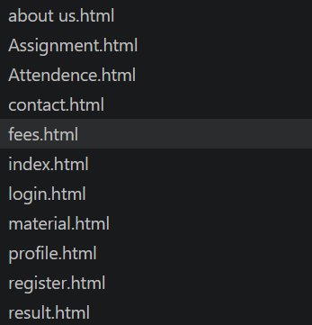

Site Map:
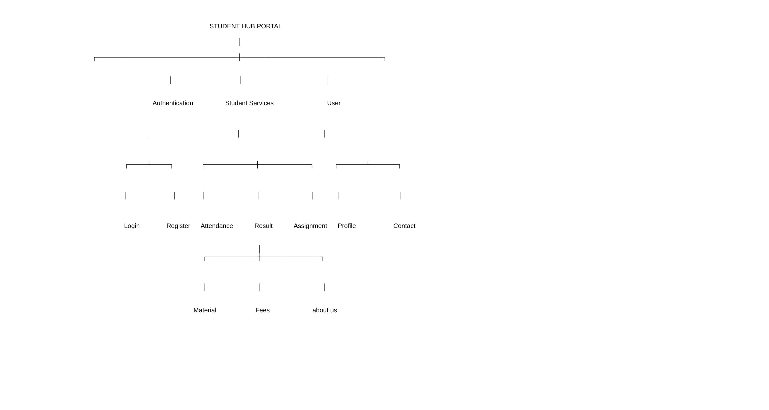

Wire frame:
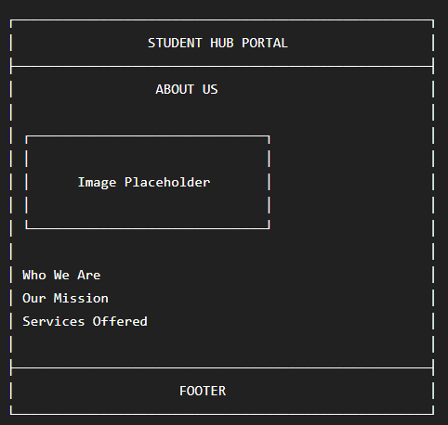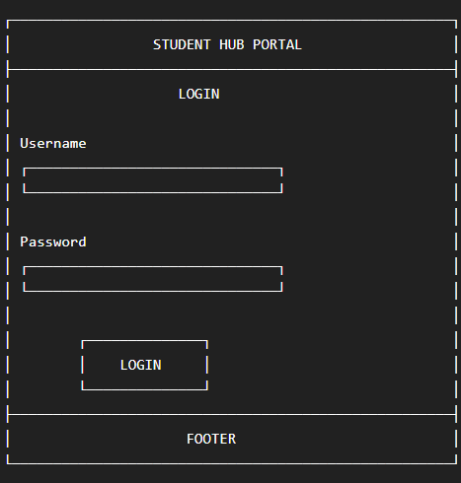
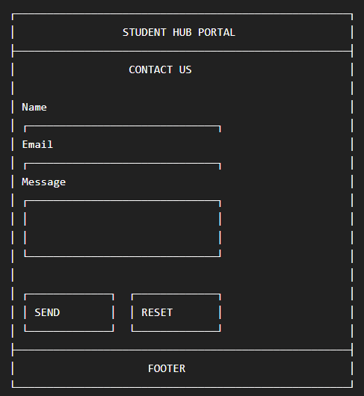
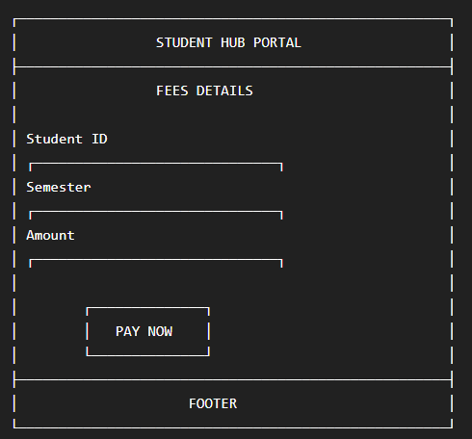
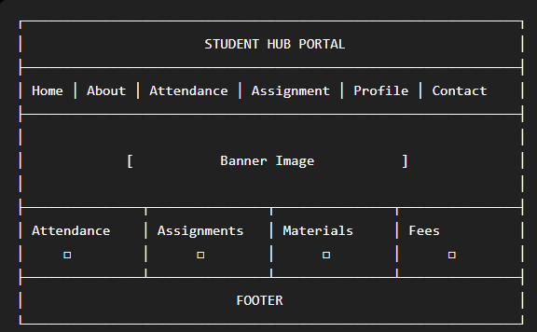

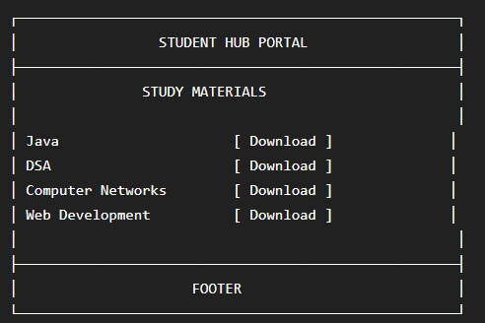

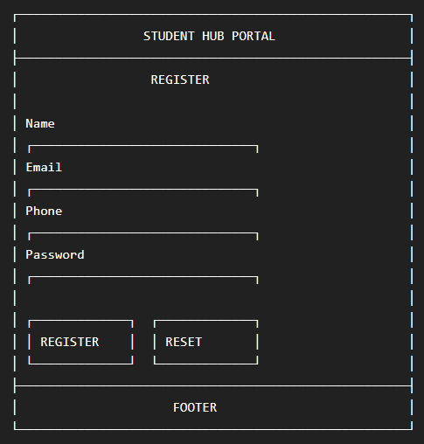

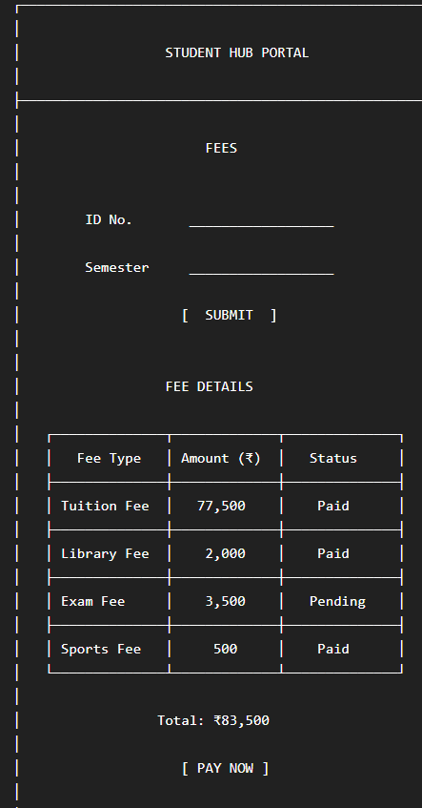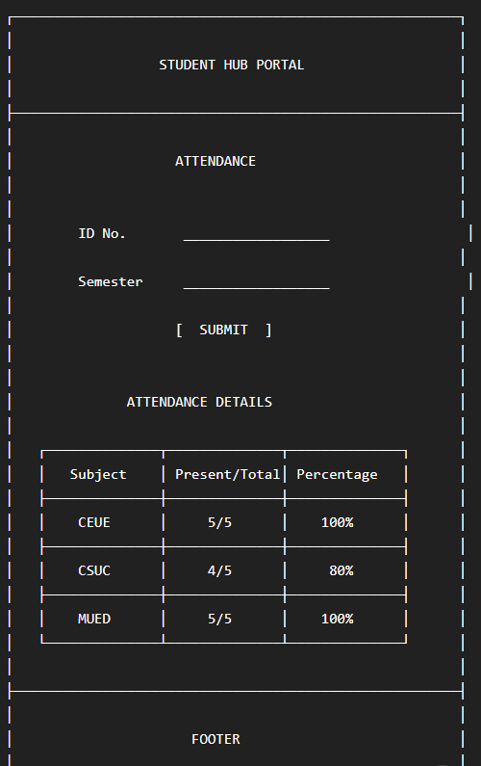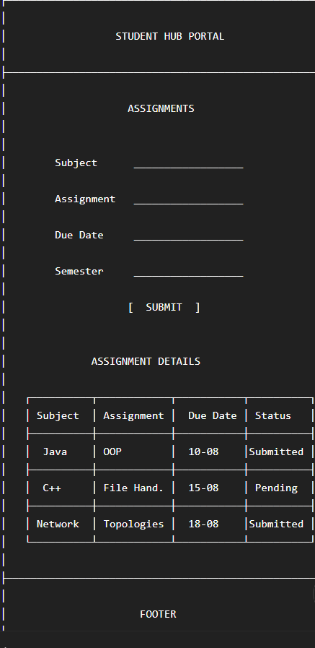

GitHub Repository Link:
https://github.com/25dce046/STUDENT-HUB-PORTAL

Challenges Faced:
GITHUB REPO. CREATION,FOLDER CREATION,FILE CREATION.
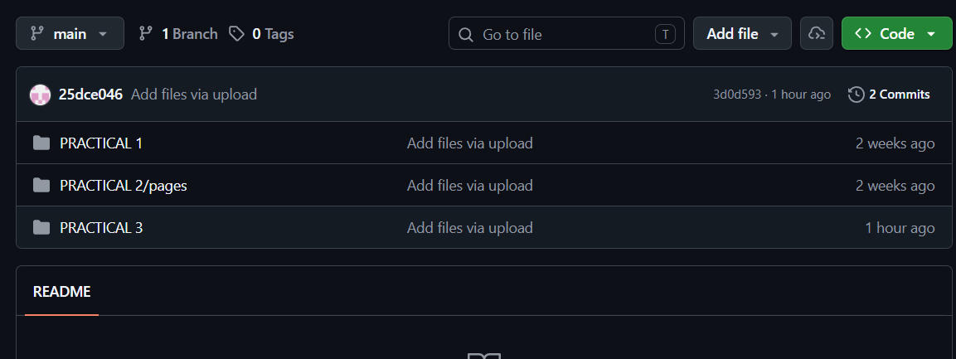

Learning Outcomes:

I LEARNED WEBSITE CREATION, SITEMAP, WIREFRAME, GITHUB, REQUIREMENT ANALYSIS, FILE MANAGEMENT.

Faculty Remarks: (Keep this blank for faculty)

